Bash Scripting Assignment Documentation
The uploaded assignment contains 7 tasks:

Task 1: Create First Shell Script (Hello World)

Outcome
Task completed successfully.

Objective
To learn this Bash scripting concept.

Prerequisites
• Ubuntu/Linux
• Bash shell
• Terminal
• Text editor (vi/nano)

Step-by-Step Implementation
Step 1: Open Terminal.
Step 2: Create script:
vi script.sh
Step 3: Write the following code:
echo 'Hello World'
Step 4:
chmod +x script.sh
./script.sh

Screenshot Evidence
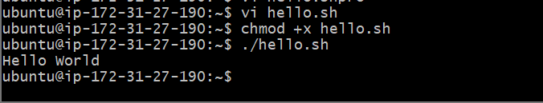

Validation Steps
Verify expected output appears without errors.

Explanation
Explain what the script does, why the commands are used, and the expected result (1–2 paragraphs).

Real-Time Use Case
Describe an industry use case for this script.

Common Errors and Troubleshooting
Error | Cause | Resolution
Permission denied | Script not executable | Run chmod +x script.sh

Task 2: Execution of Multiple Commands

Outcome
Task completed successfully.

Objective
To learn this Bash scripting concept.

Prerequisites
• Ubuntu/Linux
• Bash shell
• Terminal
• Text editor (vi/nano)

Step-by-Step Implementation
Step 1: Open Terminal.
Step 2: Create script:
vi script.sh
Step 3: Write the following code:
date
pwd
ls
Step 4:
chmod +x script.sh
./script.sh

Screenshot Evidence
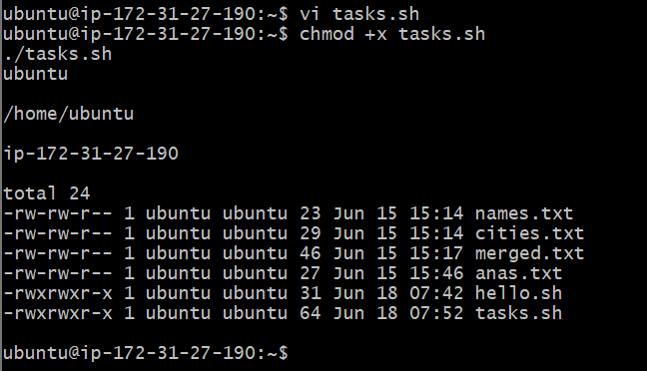

Validation Steps
Verify expected output appears without errors.

Explanation
Explain what the script does, why the commands are used, and the expected result (1–2 paragraphs).

Real-Time Use Case
Describe an industry use case for this script.

Common Errors and Troubleshooting
Error | Cause | Resolution
Permission denied | Script not executable | Run chmod +x script.sh

Task 3: Using Variables

Outcome
Task completed successfully.

Objective
To learn this Bash scripting concept.

Prerequisites
• Ubuntu/Linux
• Bash shell
• Terminal
• Text editor (vi/nano)

Step-by-Step Implementation
Step 1: Open Terminal.
Step 2: Create script:
vi script.sh
Step 3: Write the following code:
name='Anas'
echo $name
Step 4:
chmod +x script.sh
./script.sh

Screenshot Evidence
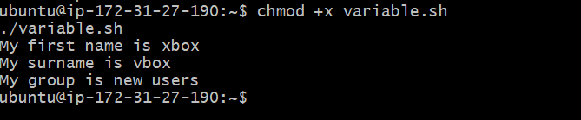

Validation Steps
Verify expected output appears without errors.

Explanation
Explain what the script does, why the commands are used, and the expected result (1–2 paragraphs).

Real-Time Use Case
Describe an industry use case for this script.

Common Errors and Troubleshooting
Error | Cause | Resolution
Permission denied | Script not executable | Run chmod +x script.sh

Task 4: Read User Input

Outcome
Task completed successfully.

Objective
To learn this Bash scripting concept.

Prerequisites
• Ubuntu/Linux
• Bash shell
• Terminal
• Text editor (vi/nano)

Step-by-Step Implementation
Step 1: Open Terminal.
Step 2: Create script:
vi script.sh
Step 3: Write the following code:
read -p 'Enter name: ' name
echo $name
Step 4:
chmod +x script.sh
./script.sh

Screenshot Evidence
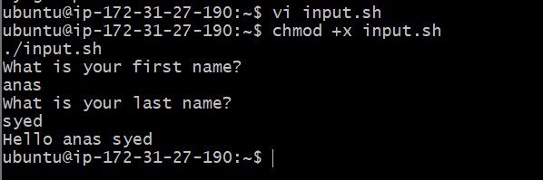

Validation Steps
Verify expected output appears without errors.

Explanation
Explain what the script does, why the commands are used, and the expected result (1–2 paragraphs).

Real-Time Use Case
Describe an industry use case for this script.

Common Errors and Troubleshooting
Error | Cause | Resolution
Permission denied | Script not executable | Run chmod +x script.sh

Task 5: Execution of Commands Inside Script

Outcome
Task completed successfully.

Objective
To learn this Bash scripting concept.

Prerequisites
• Ubuntu/Linux
• Bash shell
• Terminal
• Text editor (vi/nano)

Step-by-Step Implementation
Step 1: Open Terminal.
Step 2: Create script:
vi script.sh
Step 3: Write the following code:
files=$(ls)
echo "$files"
Step 4:
chmod +x script.sh
./script.sh

Screenshot Evidence
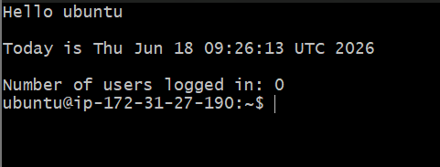

Validation Steps
Verify expected output appears without errors.

Explanation
Explain what the script does, why the commands are used, and the expected result (1–2 paragraphs).

Real-Time Use Case
Describe an industry use case for this script.

Common Errors and Troubleshooting
Error | Cause | Resolution
Permission denied | Script not executable | Run chmod +x script.sh

Task 6: Rename a File Using User Input

Outcome
Task completed successfully.

Objective
To learn this Bash scripting concept.

Prerequisites
• Ubuntu/Linux
• Bash shell
• Terminal
• Text editor (vi/nano)

Step-by-Step Implementation
Step 1: Open Terminal.
Step 2: Create script:
vi script.sh
Step 3: Write the following code:
read old
read new
mv "$old" "$new"
Step 4:
chmod +x script.sh
./script.sh

Screenshot Evidence
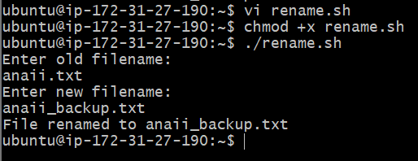

Validation Steps
Verify expected output appears without errors.

Explanation
Explain what the script does, why the commands are used, and the expected result (1–2 paragraphs).

Real-Time Use Case
Describe an industry use case for this script.

Common Errors and Troubleshooting
Error | Cause | Resolution
Permission denied | Script not executable | Run chmod +x script.sh

Task 7: Create Directory if Not Exists and Copy File

Outcome
Task completed successfully.

Objective
To learn this Bash scripting concept.

Prerequisites
• Ubuntu/Linux
• Bash shell
• Terminal
• Text editor (vi/nano)

Step-by-Step Implementation
Step 1: Open Terminal.
Step 2: Create script:
vi script.sh
Step 3: Write the following code:
mkdir -p backup
cp file.txt backup/
Step 4:
chmod +x script.sh
./script.sh

Screenshot Evidence
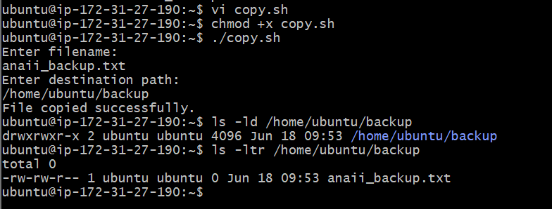

Validation Steps
Verify expected output appears without errors.

Explanation
Explain what the script does, why the commands are used, and the expected result (1–2 paragraphs).

Real-Time Use Case
Describe an industry use case for this script.

Common Errors and Troubleshooting
Error | Cause | Resolution
Permission denied | Script not executable | Run chmod +x script.sh

